DATABASE SECURITY IN DATABASE
MANAGEMENT SYSTEM

NEERAJA KARETI
Department of Computer Scinece
Southeast Missouri State Univeristy
Cape Girardeau, Missouri, United States Of America
nkareti1s@semo.edu

Abstract— Twenty-first century has come along with advanced gadgets such as phones, computers and other devices that are a threat to information in databases. Data security therefore in this era of advanced technology and internet accessibility is very vital. Firm methods of data protection need to be installed or reinforced to make sure that the information so stored in the database management systems is secure and free from threats. Cyber robbery is one of the major causes of data leakage, the article will address other modes which necessitate the need for data security in the data management system. Additionally, this research will cover the data security concept, the various types of data security and the layers of data security. Finally, the research will cover several methods that may be used to prevent data leakage and data loss, measures against data threats and finally the principles of integrity in the data security system. The research mainly adopts a qualitative research approach where information will be obtained from EBSCOhost database and the Google Scholar for all the articles that are covered in the paper. Additionally, more research will be done in other online sites and books to ensure credibility as well as the reliability of the data used. Thematic as well as content analysis method is used to extract the themes, objectives and the research questions used in the articles. Relevant literature from different sources is retrieved through the preparation of reading sheets. The research will finally discuss the main key areas identified above as part of the findings. Recommendations will be provided which will help contribute to the theory of data security.

Keywords—data security, database threats, security techniques, integrity, database management system

Introduction
Notably, organizations both small and medium-sized, and large ones have been utilizing the database systems to maintaining their daily activities. These activities include private transactions of the organizations as well as operations. In such cases, the security of the database by which this information is captured becomes a very vital issue that should be addressed. However, despite the database been the arc of the organization, it is, the most vulnerable sector which undergoes misuse day by day by both external and internal threats.
Companies and other organizations have however been concerned in ensuring that they secure their databases which indeed is a very tough issue. This comes by the act that the security measures tend to be tough depending on the size of the database that needs to be secured. However, it is
these security measures that act as the heart of every database system and in every phase. In return to the needs of enhanced security measures, the need of modern techniques that will help manage and achieve fortification in terms of protection.
Sorting database security, therefore, has become a very important factor that organizations need to enhance to run their operations effectively. This calls for the effort of the organization to ensure that the data is safe from both intentional and accidental threats that may arise. The threats pose challenges to the organizational operations which might lead to tangible losses as well as intangible losses such as distrust from customers. This especially comes to consumers who are very sensitive to security measures in any given organization. To ensure that this is not the case, firms have embraced a very firm decision regarding database security and protection through frequent controls and checks to maintain the integrity of the information and ensure that the information system is closely monitored as measures of keeping off any unauthorized intruder.
The research paper, therefore, tries to address some of the database security threats and the techniques used in data security. These techniques are conclusively used to come up with solutions that will ensure the safety of the data which can only be brought by the threats. Therefore, the paper aims at providing a simple model that can be used to come up with strong database security is implemented by identifying the leakages and injections in the dataset management system. The rest of this research paper has been sub-divided into three parts; the literature review is broken into two, the methodology and the discussion part which constitutes the general overview of the database security, the conclusion, and the recommendations.

Techniques for database security
Database security needs to employ various techniques. These techniques refer to the methods that help improve the environment that the data has been preserved by ensuring that the information is free from contamination. These techniques include may be summarized by the chart below and later discussed in Fig 1.

Database authorization; This is a data security system which incorporates the idea of keeping data in a safe and secure locked environment that is fitted with security controls. This method aims at keeping non-authorized people out of reach of the data through using a separate physical machine
.
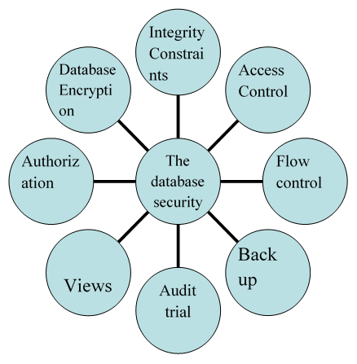

Fig 1. Database Security Techniques [10].

Data encryption: This is a method applied in data security whereby a person is required to produce a verification code before accessing the data. This method is used to secure the stored as well as the backed-up data using separate codes and encrypting data in motion over a network to ensure that it is against any threats.

Back up of database: This is a method of securing data that involves creating a copy of the original data to act as a backup in case the original data gets corrupted or crashes or even gets lost. Back up data is updated time by time to ensure that it is up to date and covers every aspect of the database.
Audit trial: This is a technique of security data that involves monitoring attempted logins to a system that contains the data. This process should spot every attempt to compromise or an attempt of suspicious activities. Audit trial is the most effective method of database security as it enables one using database activity monitoring (DAM) types. of software to determine every instance of account sharing and new account creation.

Flow control: This refers to a technique of database security that manages how data is flowing between one node and the other. When too much data arrives into a system that is not able to handle the whole of it at a go, it causes data overflow which translates to data losses or transmissions. Under these circumstances additionally, most of the hackers get a chance to divert some of the data into their channels resulting to either permanent losses if there wasn't any backup or corrupted data or leaked information.

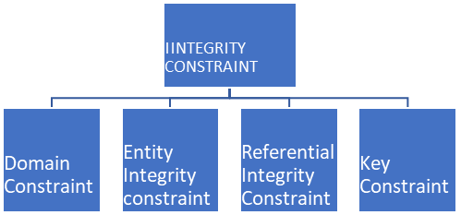
Fig 2. Integrity Constraints [10]

Access control: This is a technique that regulates or controls anybody or anything that tries to access any kind of information. This technique is employed in different organizations to minimize the risk of data insecurity in three layers namely; the Discretionary Access Control (DAC), Mandatory Access Control and finally Role-Based Access Control (RBAC).

Views: This is a database security technique that is used to combine data from tables using joins thus making the data conveniently hidden for complex queries. Views are created using a CREATE VIEW command from queries.

Integrity constraints: Integrity constraints in database security involves a set of guidelines that monitors information quality. This technique ensures that every update on the database including data assertion is done in a way that it does not affect the existing data. Integrity constraint can be further branched as shown in the Fig 2.

Security Audit
The security audit will be using the recorded and analyzed historical data for improving the system’s performance based on some security policy. Security audit will have the testing, assessing and analyzing for identifying the weak links exist in the network so that it will not disturb the normal operation of the business and it will guarantee the safety of data within an organization. It will ensure the safe operation within network information system, will preserve the confidentiality, availability and integrity of the data, will prevent the human error which might happen intentionally or unintentionally and will detect any criminal attacks that happens in the network. The tracking of network status will be using audit mechanism to identify any issues in network and will provide the safety to the network based on the tracked results. Additionally, the audit will be providing the filtering option for the online information. When the harmful information identified in website, will be added to route filtering which will reject all the information that is available on the filtering list of the IP address by using filtering mechanism.

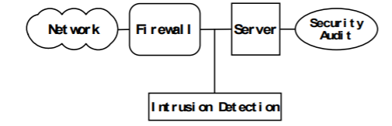
Fig 3. Security Audit Simulation in Network[9].
Security audit process have the two modules which are collection of information and security audit. Thw structure is shown in Fig 4.

Threats of database security
Issues related to the database have become more complicated considering the widespread utilization of distributed server or client architecture contrary to the use of mainframe systems. Information may be regarded to be a firm main resource and is contained in a database and henceforth there needs strategies and procedures through which database system should be safeguarded and the data it contains to maintain integrity. There has been an increase in the accessibility of database after the rampant increase in speed as well as usage of internet and intranet which therefore increases the risk of having the data with unauthorized person.

Threats pose risks to the reliability and the integrity of the data besides database security main objective been to safeguard data against any losses whether intentional or accidental. Well-Managed database security will grant access to the authorized parties of the data while denying others the same access as Singh (2009) suggests. Such actions of control are the techniques mentioned above in the
paper. However, despite the attempts to safeguard data there are different threats that threaten database system

The first threat is the loss of data which means that the data becomes unavailable. Data loss mostly is associated with changes in the hardware that is used to store the data, application failures or network failures. The data loss may not only bring to a stop the operations of an organization but also impede the daily activities. Additionally, the data loss may be brought along by what he calls excessive privileges- a situation where a person is associated with the activity he is not supposed to be at and ends up messing with the data.

The second threat arises from a weak audit trial whereby an organization gets exposed to various risks as a result of internal weaknesses. These weaknesses arise as a result of feeble deterrence mechanisms. A weak audit trial brings to light the information regarding an organization thus threatening the security of a database system of the organization.

Finally, there is a weak system of authentication threat. A weak system may result in unauthorized persons accessing information and even change the credentials that have been used to envisage the information. This threat is closely associated with denial of service threat whereby hackers and people who might need access to the data might be probed into looking for more means of authentication.

DATABASE SECURITY ARCHITECTURE
To ensure that the database is secure, there should be utilized a good database security architecture that revolves around four pillars as shown below in the Fig 5. Assessment and analysis: this are the first pillar of the architecture which involves activities of assessing the database model and the database security. This pillar is used to check any attempts of data accessibility, threats and the vulnerability of the database system. This pillar employs a thorough and exclusive audit trial of both the micro and macro environment of the database.

The next pillar is design and modeling the database system. In this pillar, policies and prototypes are created which aligns with the needs of an organization. Additionally, this stage involves defining the software which paves a way for the tools of mitigating the risk. The third pillar is deployment. At this pillar, tools and applications that were previously formulated after defining the software are exercised.

At this stage, the simulations are made that help in testing how robust the system is as well as identifying cases of an unforeseen variable. The last pillar is the management and support where there is continuous support of the database system already deployed. Management ensures that the system is monitored to ensure that if there are any changes that are needed, they are made effectively and efficiently. This pillar needs reassessment with time as it starts the security life cycle again.

The paper therefore has generally discussed the database security concerns and researched into various issues that surround the area of interest. As can be seen, small and middle-sized and even large organizations in making choices rely on data which as well enhances their operations. That been shown therefore it is very important keeping every sensitive information off from the hands of unauthorized persons to prevent loss of confidentiality as well as data integrity.

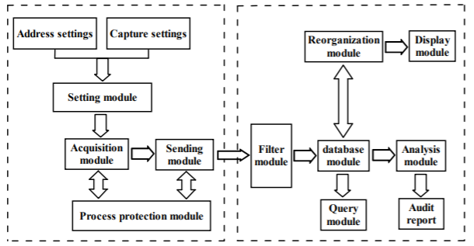

Fig 4. Security Audit System

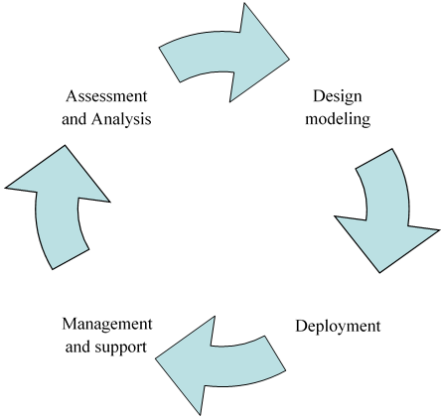

Fig 5.Database Security Architecture[10]

Advantages of the database management system
A database management system helps in creating a conducive environment in which every data user or the end user can easily access a well-managed and bulk information. This is not only time saving but also enables the end users to quickly respond to any changes in the environment.

DBMS additionally improves the security of the data through restricted access. This comes with the fact that the more the number of people accessing information, the more the risks of damage. This in mind, the DBMS helps in coming up with a framework that better enhances information privacy through the application of the above-said techniques.

A DBMS ensures that data maintains its integrity. When security policies are formulated and implemented in the database systems, there emerges an integrated view of the operations within an organization which makes it possible to identify the effects of one sector in an organization to the other. Additionally, under integrated data, DBMS ensures that there is data consistency whereby the same versions of the data are maintained in the necessary area
.
Finally, the DBMS ensures that there is improved data access. This ensures that answers are provided for specific requests. This becomes an added advantage to an organization through an improved decision-making procedure. Better accessibility to data ensures that the information so obtained is reliable and hence promotes in reaching better decisions for an organization. Better decisions in an organization are helpful in ensuring that there is increased productivity as the decisions determine the success or the failure of the operations of an organization.

Requirements for Database Security
Before accessing the system, user requires user authentication and identification. There are different methods to provide the authentication to users like passwords, biometrics, passcode or signature reading devices. These will be needed to have a better user management. The other requirement will be authorization and access controls. The rules for this will provide who can access the what information and their access level to the information. The access control will govern the authorization for the user. The database operation must have the integrity and consistency operation in the database. The database should have the correct set of rules to protect from the malicious attack. Final, requirement for the database will be auditing. This is most needed because in order to review and to check the efficiency of control system and it will suggest the better actions.

Database security guidelines
To serve the database as central repository for data, the user must have trust on accuracy of the data values. It states that database administrator must be aware that only authorized person can perform the update operation in the database. The DBMS require the very strong user authentication methods. For instance, the DBMS will ask the user to provide both the password and the time-of-day checks. This type of authentication will provide additional authentication on the operating system.

Databases will be categorized based on the privilege access given to the users. For example, the information which is general can be given access to all the users, access to data on salary will be given to the salary department and sales data access will be provided to sales department. The usefulness of the database will be it provides the centralized storage in data and will provide the maintenance of the data. The database protection will be ensured by the database integrity to avoid from the damage in the disk or from the corruption in master disk. The integrity controls and procedures in the operating system will handle those concerns. Storage of sensitive information will be in a table form that will be encrypted with unique key.

database security levels
Security measures must be taken at security levels in order to protect the database.

- People: The authorization of the user has been done carefully in order to reduce the chance of getting the unauthorized access.
- Operating System: More secure in the database has no need when there is weakness in the operating system. It will serve as the unauthorized access to the database.

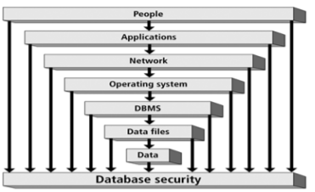

Fig 6. Database Security Level [11]

- Database System: The user in database system will have access to the limited portion in the database. It means that user will have access to perform the queries in the database, but they are restricted to modify the data. data security and different types of threat involved in database.

The integrity principles in database security
Data integrity can be summarized by the accuracy and the reliability of the information that is in the database and the usefulness of the information to the business. In ensuring that the data is reliable and accurate, several guidelines need to be followed. The first one is through the use of well-articulated transactions meaning that the data should be free of any manipulations. This helps in ensuring that’s the data is accurate and hence promotes integrity.
Secondly, there should be divisibility of duties through specialization whereby the individual can be judged of assets misuse separately. Finally, there should be a structure which delegates duties. Delegation of duties will ensure that there is continuity in the operations of an organization.

DATABASE VULBERABILTIES
The common security vulnerability involved in database will be below one
SQL Injection: Database attacks are mostly will occur from the cybersecurity breaches. SQL injection will allow the system access to unauthorized users.
Inadequate auditing: The database requires the audit to be tracked when data is being accessed. When system do not have the auditing mechanism then the system will be more exploit to vulnerabilities.
As shown in Fig 7, the default and weak password will allow the hackers to hack the system easily. The hacker will have the unauthorized access by trying different types of attack to steal the password.

LITERATURE REVIEW
The database will be acting as a backbone for all types of the application. For most of the organization the primary way of storage will be in the database. So, there are more chances of attack in database due to sensitive and confidential information of an organization stored in the database. The data in the database can be compromised in many ways. This paper discussed about the different levels
of security, the techniques in data security and different types of threat involved in database.

METHODOLOGY
The research adopted a qualitative research approach and broke the information into three stages. These stages are the analytical stage, which involved information analysis. This triggered the development of reading sheets and an excel file to be used further in the next stages. The
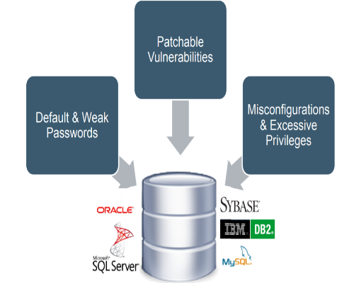

Fig7..Database Vulnerabilities [13]

second stage is the synthesis stage which involved synthesizing the information so obtained in stage one through thematic and content analysis to retrieve the relevant data. Finally, there was the critical appraisal stage that involved deducing the related information as well as the application of deductive reasoning to come up with the information for this research paper. The paper also adopted an observation method partly as the project is mostly based on programming especially the techniques used in the database security.

CONCLUSION
Some human errors are said to be accidental through wrong methods of input and wrong applications. Database security as seen may be threatened by various factors that are software generated as well as natural threats. All these threats in database security considered as matters of concern. Therefore, database security involves restoring the database to an initial safe mode before a failure. To build a strong robust system, there are various steps that need to be incorporated while others enforced.

The research identified one of the main steps that need being addressed in addressing issues related to database security as normalization of database which should always be done before use to enforce database functionality and avoid niches. Additionally, the research identified a threat of denial of access to the database. This can be addressed by allocating privileges to different users which will make them not to develop the mentality of hacking and weakening the authentication procedure.

Audit control measures need to be enhanced by been enforced such that the operating system gains the capability of ensuring that there is user verification in every program that attempts accessing the database system. This work should be handled by an administrator who should keep accounts and every credential login and ensure confidentiality and accountability

REFERENCES
[1] A. Basta, and M. Zgola, Database security Cengage Learning, 2011.
[2] Bertino et al Database security-Concepts, Approaches and challenges IEEE Transactions on Dependable and secure computing, 2005.
[3] Coronel et al Database System Design, implementation and management Cengage Learning, 2012.
[4] Data & Information Technology. Salem Press, 2014. EBSCOhost, search.ebscohost.com/login.aspx?dir ect=true&db=nlebk&AN=777854&s ite=ehost-live.
[5] Fogelman-Soulié, Franç oise, and North Atlantic Treaty Organization. Mining Massive Data Sets for Security : Advances in Data Mining, Search, Social Networks and Text Mining, and Their Applications to Security. IOS Press, 2008.
[6] Kumar et al ManaginCyberthreatsts: Issues, Approaches and Challenges Springer Publishers, 2005.
[7] P, Singh Database management system concept V.K (India) Enterprises, 2009
[8] S. Singh, Database systems: Concepts, Desi, n and applications New Delhi: Pearson Education India, 2009.
[9] S. Sumanthi, Fundamentals of relational database managementsystems Berlin: Springer, 2007. 38(21), 4996–5007.

10] a Threat to Cyber Banking in South Africa: An Approach to Network and Application Security, 18 August 2016, INSPEC Accession Number: 16232925.

11] “Security in Computing” 4th edition Mr.Charles P.Pfleeger-Pfleeger Consulting Group, Shari Lawrence Pfleeger.

[12]EmilBrtescu,“DATABASE SECURITY - ATTACKSAND CONTROL METHODS”, Journal of Applied Quantitative Methods, Vol. 4, no. 4, Winter 2009.

